SR UNIVERSITY
AI ASSIST CODING
Lab 4: : AI-Based Code Auto-Completion – Classes, Loops, and Conditionals in Python using GitHub Copilot
Name: D.SIDDHARTHA
Pin No.: 2503A51L04
Task 1: Auto-Complete a Python Class for Bank Account
Prompt: Write a class definition comment and start the constructor for a class called BankAccount with account_holder and balance attributes. Use GitHub Copilot to auto-complete the rest of the class, including methods to deposit, withdraw, and display balance.
Python Code:
class BankAccount:
"""A simple Bank Account class with deposit, withdraw, and display balance methods."""
def __init__(self, account_holder, balance=0):
self.account_holder = account_holder
self.balance = balance
def deposit(self, amount):
self.balance += amount
return f"Deposited {amount}. New Balance = {self.balance}"
def withdraw(self, amount):
if amount > self.balance:
return "Insufficient funds"
self.balance -= amount
return f"Withdrew {amount}. Remaining Balance = {self.balance}"
def display_balance(self):
return f"Account Holder: {self.account_holder}, Balance: {self.balance}"
Explanation: The class has attributes for account holder and balance. Methods allow deposit, withdrawal with balance check, and displaying account details. 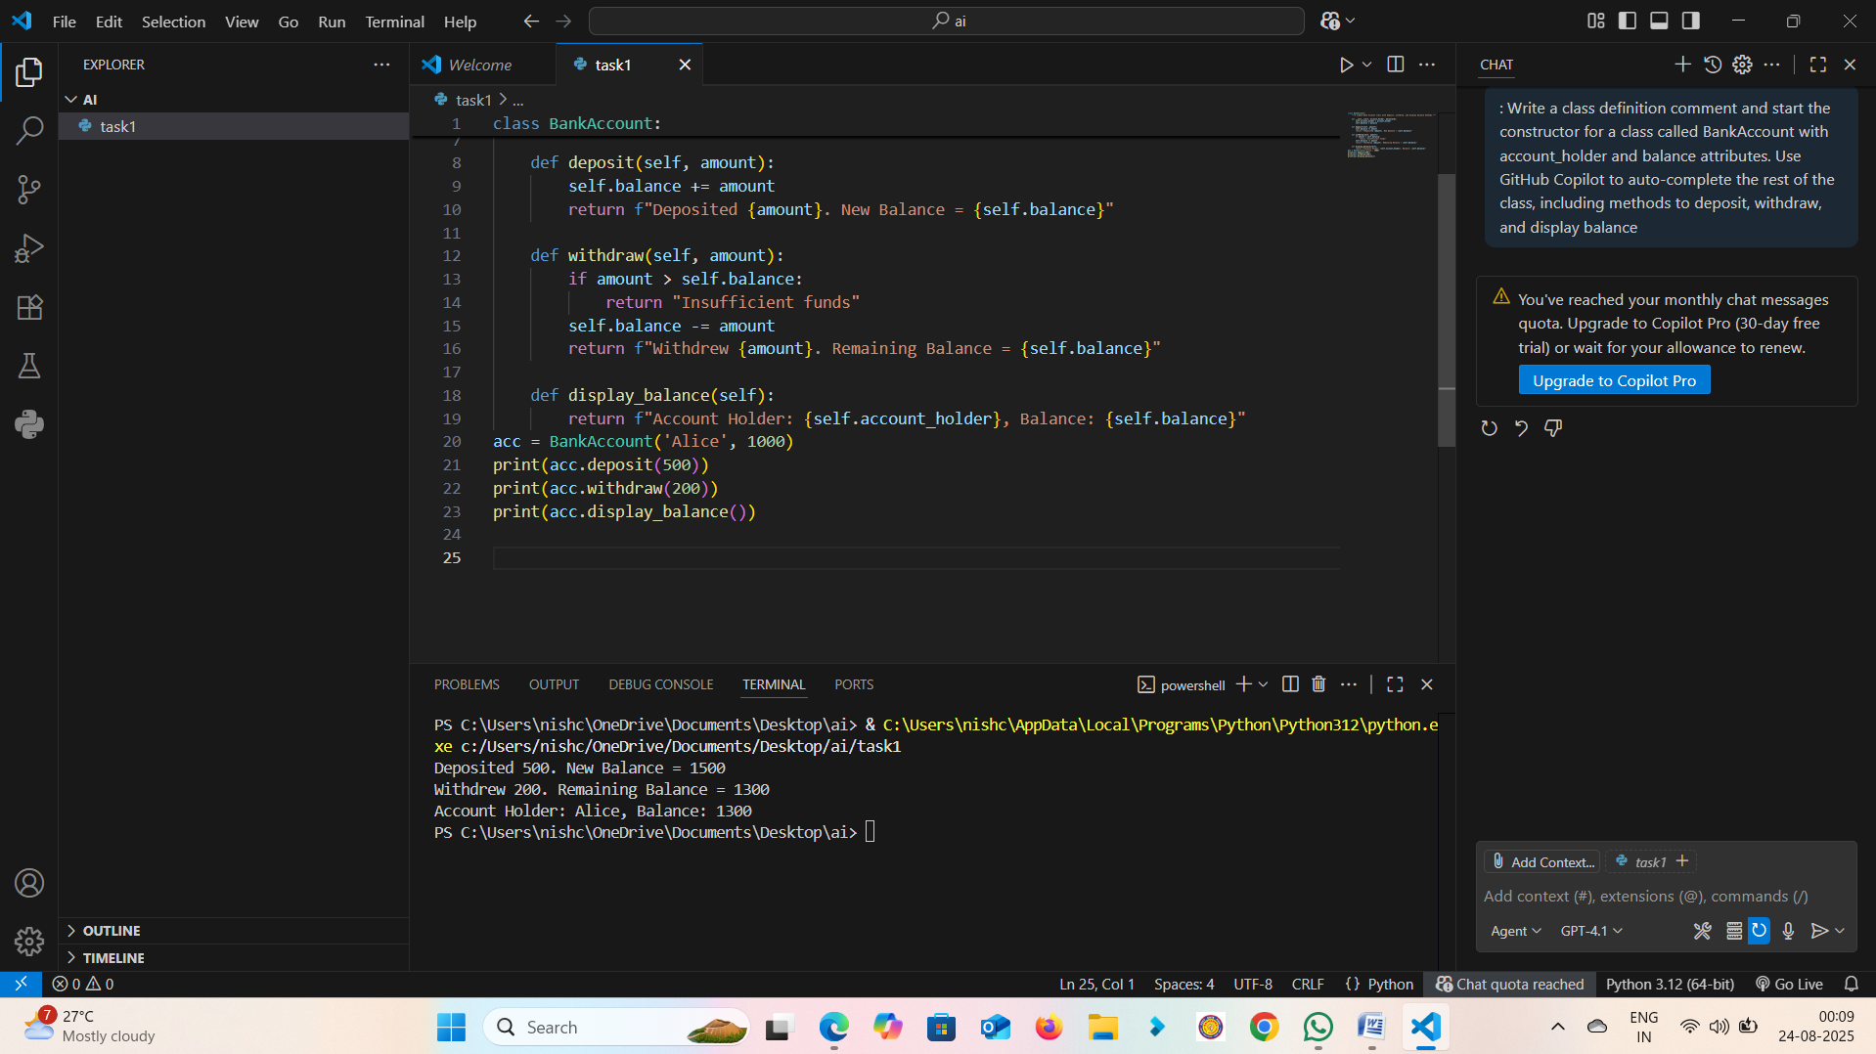
Output:
>>> acc = BankAccount('Alice', 1000)
>>> print(acc.deposit(500))
Deposited 500. New Balance = 1500
>>> print(acc.withdraw(200))
Withdrew 200. Remaining Balance = 1300
>>> print(acc.display_balance())
Account Holder: Alice, Balance: 1300
Observation: The BankAccount class successfully handled deposits, withdrawals, and displayed balance accurately.
Task 2: Auto-Complete a For Loop to Sum Even Numbers in a List
Prompt: Write a comment and the initial line of a loop to iterate over a list. Allow GitHub Copilot to complete the logic to sum all even numbers in the list.
Python Code:
numbers = [1, 2, 3, 4, 5, 6, 7, 8, 9, 10]
even_sum = 0
for num in numbers:
if num % 2 == 0:
even_sum += num
print("Sum of even numbers:", even_sum)
Explanation: The loop iterates through the list, checks if each number is even, and adds it to the running sum. 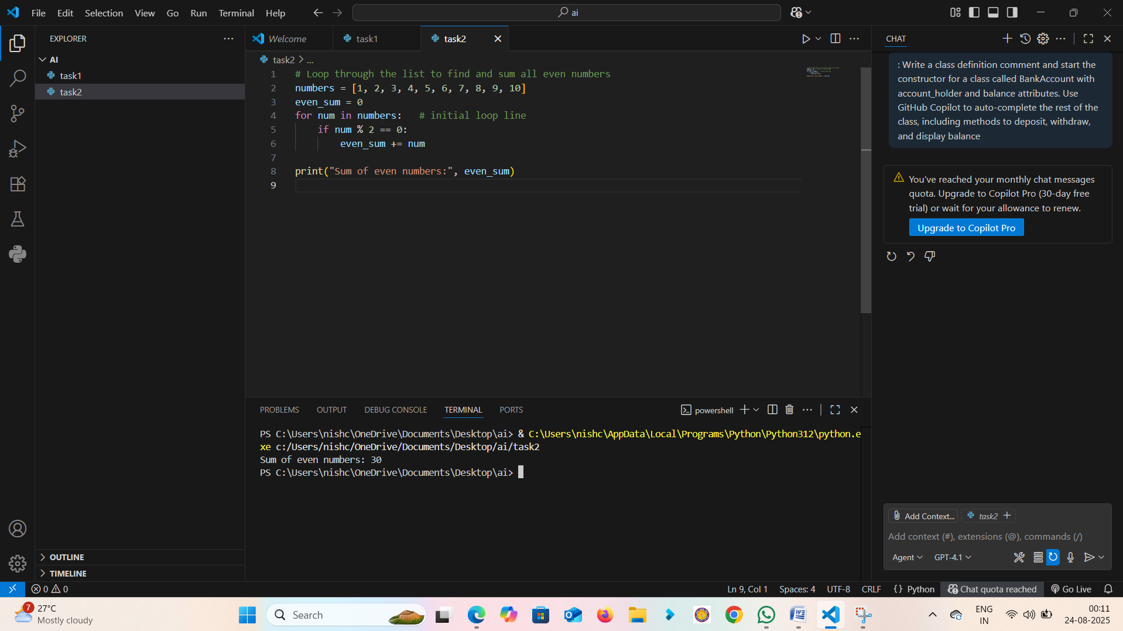
Output:
Sum of even numbers: 30
Observation: The loop correctly iterated and summed even numbers from the list.
Task 3: Auto-Complete Conditional Logic to Check Age Group
Prompt: Start a function that takes age as input and returns whether the person is a child, teenager, adult, or senior using if-elif-else.
Python Code:
def age_group(age):
if age < 13:
return "Child"
elif age < 20:
return "Teenager"
elif age < 60:
return "Adult"
else:
return "Senior"
Explanation: The function uses if-elif-else conditionals to classify age groups.
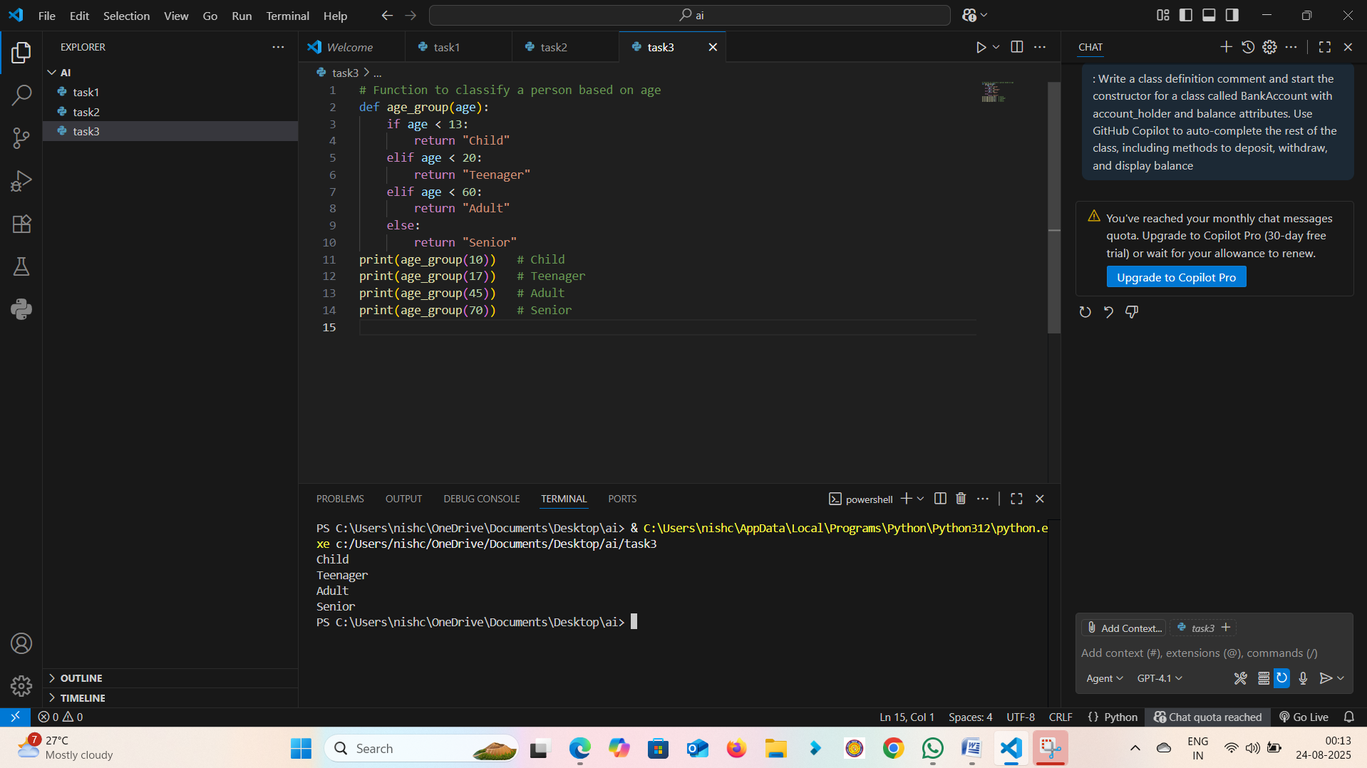
Output:
>>> age_group(10) -> Child
>>> age_group(17) -> Teenager
>>> age_group(45) -> Adult
>>> age_group(70) -> Senior
Observation: The function correctly classified age groups based on input values.
Task 4: Auto-Complete a While Loop to Reverse Digits of a Number
Prompt: Write a comment and start a while loop to reverse the digits of a number.
Python Code:
num = 1234
reverse_num = 0
while num > 0:
digit = num % 10
reverse_num = reverse_num * 10 + digit
num //= 10
print("Reversed Number:", reverse_num)
Explanation: The loop extracts the last digit using modulo, builds the reversed number, and reduces the original number using integer division. 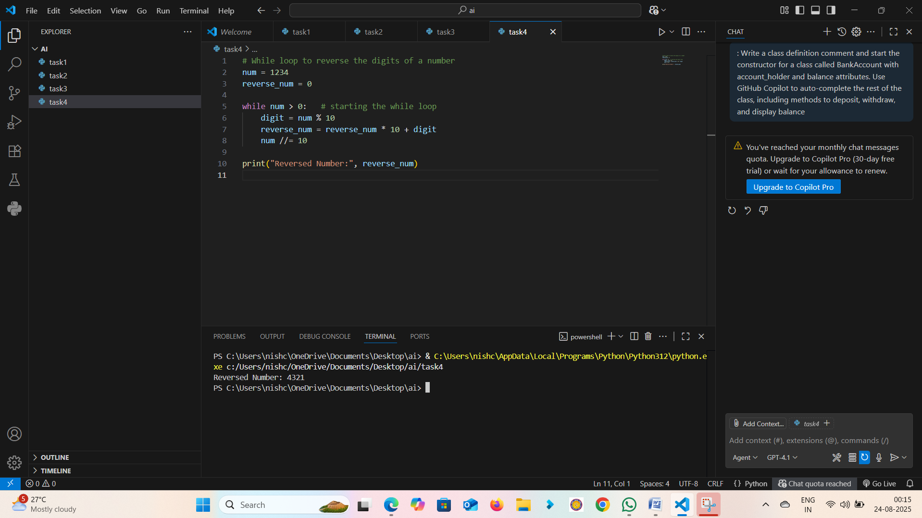
Output:
Reversed Number: 4321
Observation: The while loop reversed the digits of the number without errors.
Task 5: Auto-Complete Class with Inheritance (Employee → Manager)
Prompt: Begin a class Employee with attributes name and salary. Then, start a derived class Manager that inherits from Employee and adds a department.
Python Code:
class Employee:
def __init__(self, name, salary):
self.name = name
self.salary = salary
def display(self):
return f"Name: {self.name}, Salary: {self.salary}"
class Manager(Employee):
def __init__(self, name, salary, department):
super().__init__(name, salary)
self.department = department
def display(self):
return f"Name: {self.name}, Salary: {self.salary}, Dept: {self.department}"
Explanation: The Manager class inherits from Employee using super() for constructor chaining and overrides the display method.
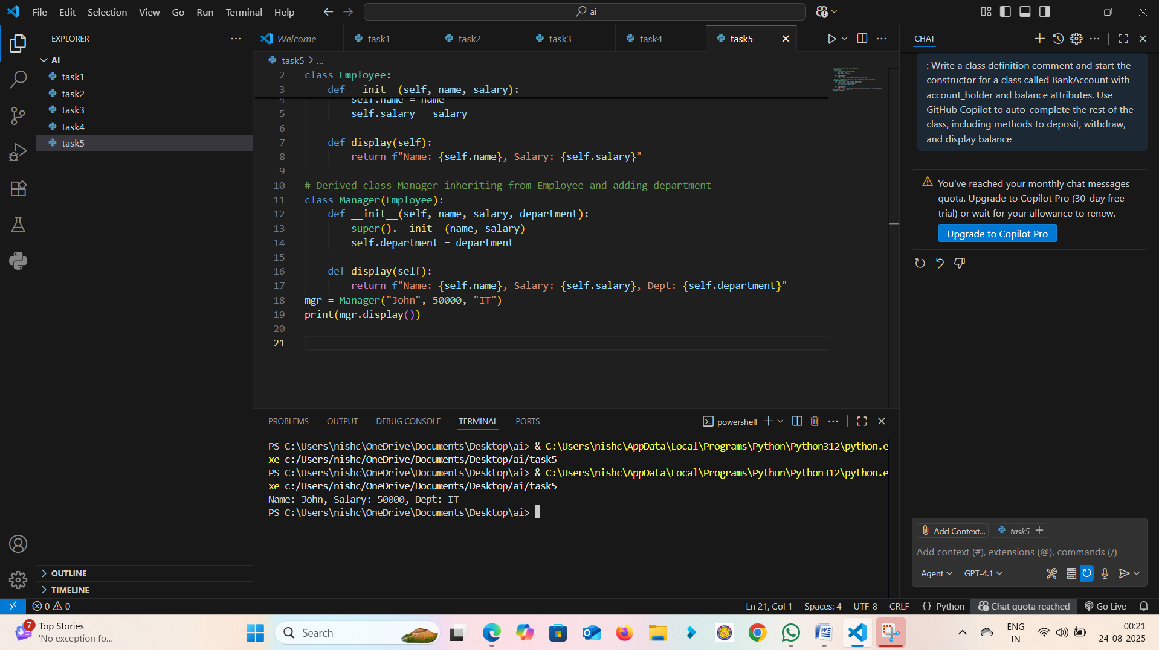
Output:
Name: John, Salary: 50000, Dept: IT
Observation: The Manager class inherited Employee attributes and methods correctly while extending functionality.
OBSERVATION……..
In this lab, we explored GitHub Copilot's ability to auto-complete Python code for classes, loops, and conditionals. We practiced building classes with inheritance, loops for summing and reversing, and conditional logic for classification. This enhanced understanding of AI-assisted coding and Python fundamentals.

